**Assignment 1 – Module 1**

**Ans:**

* Based on discount percentage of revenue, the camera and video Equipment are the least profit making subcategories that can easily be seen by the darkest green color (discount rate 8.2% and 7.6% respectively). They are followed by Electronic-Miscellaneous and TVs.

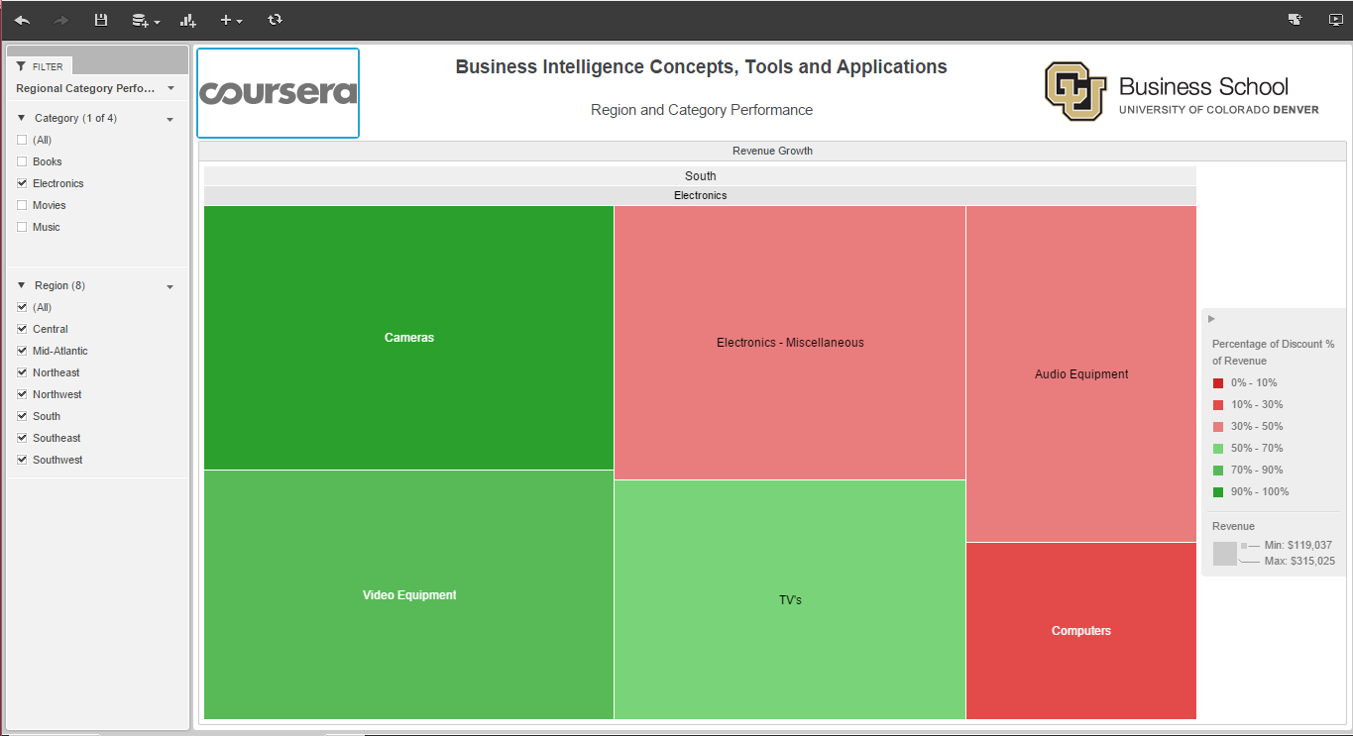

* Based on percentage growth, Electronics – Miscellaneous have the highest growth percentage of 27.88%

